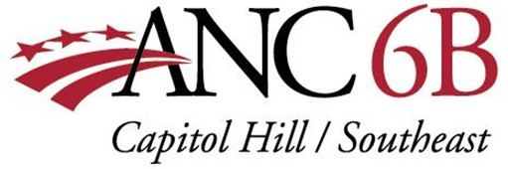

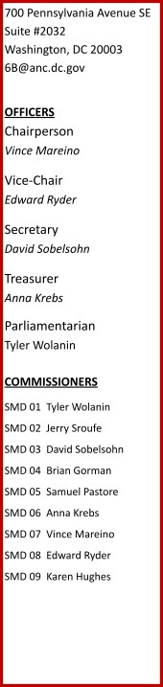March 7, 2025

Zoning Commission  
District of Columbia Office of Zoning  
441 4th Street NW, Suite 200S  
Washington, DC 20001

via email at dcoz-bzasubmissions@dc.gov

RE: Zoning Commission Case 24-21, DOC Annex

To the Board of Zoning Adjustment (BZA):

At a properly noticed general meeting on January 14, 2024, with a quorum present, Advisory Neighborhood Commission (ANC) 6B voted 9-0-0 to report to the Zoning Commission that it supports Zoning Commission Case 24-21 regarding the DC Department of Corrections proposal for the DC Jail site at 1900 Massachusetts Ave SE.

ANC 6B’s delay in reporting our support was administrative. When DC Department of Corrections and its consultants presented the project to our ANC, our only note was that we will seek further conversations among the DC Department of Corrections and the other two ANCs covering this neighborhood (ANC 7D and 7F), so that we can help make the construction process easy on all the neighbors. The need for further conversations, however, in no way changes the fact that our ANC fully supports this critical early step of approving Zoning Commission Case 24-21.

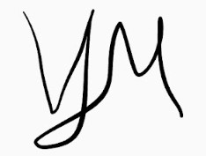Sincerely,

Vince Mareino Chair, ANC 6B